Grandparents

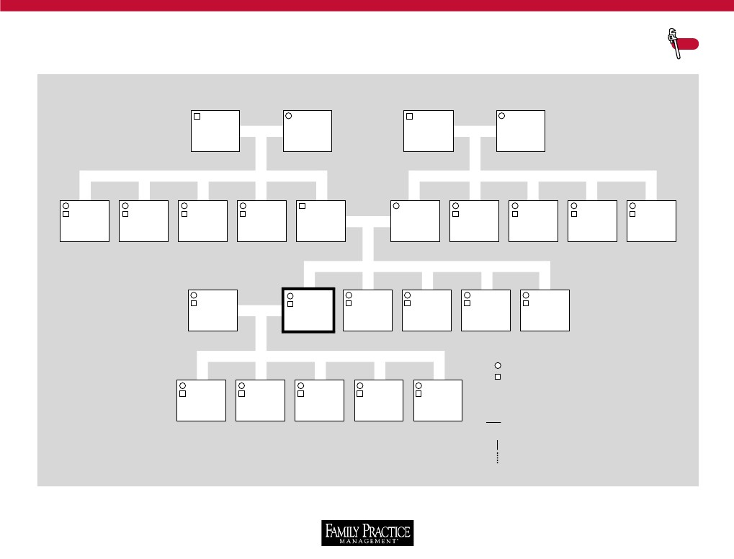
GENOGRAM TEMPLATE
FPM
Tool
-------------------------------------------------------------------------------------------------------------------------------------

Grandparents
Aunts / Uncles
Father
Mother
Aunts/ Uncles
Spouse
Patient
Siblings
GENOGRAM KEY
Children
X
D
b
– / /–
Female
Male
Deceased
Year of death
Year of birth
Committed relationship (i.e., marriage)
Broken relationship (e.g., divorce)
Biological relationship (e.g., child)
Special relationship (e.g., adoption)
Copyright © 2001 American Academy of Family Physicians. Physicians may photocopy or adapt for use in their own practices; all other rights reserved.
“Focus on the Family, Part I: What Is Your Family Focus Style?” Gotler RS, Medalie JH, Zyzanski SJ, Kikano GE, Acheson LS, Stange KC. Family Practice Management. March 2001:49-50, http://www.aafp.org/fpm/20010300/49focu.html.

